**DAILY ONLINE ACTIVITIES SUMMARY**

|  |  |  |  |  |  |  |  |  |
| --- | --- | --- | --- | --- | --- | --- | --- | --- |
| **Date:** | **30/06/2020** | | | | | **Name:** | **PRANEETA P HANDRAL** | |
| **Sem & Sec** | **4​th​ SEM. & ‘B’ SEC.** | | | | | **USN:** | **4AL19CS401** | |
| **Online Test Summary** | | | | | | | | |
| **Subject** | | **_ _ _** | | | | | | |
| **Max. Marks** | | **30** | | **Score** | | | **_ _** | |
| **Certification Course Summary** | | | | | | | | |
| **Course** | **Introduction to Data Science** | | | | | | | |
| **Certificate Provider** | | | **Cognitive class** | | **Duration** | | | **3 Hrs.** |
| **Coding Challenges** | | | | | | | | |
| **Problem Statement:** Write a C++ Program to Move all zeroes to end of array using Two-Pointers  Given an array of random numbers, Push all the zero’s of the given array to the end of the array. For example, if the given arrays is {1, 0, 2, 6, 0, 4}, it should be changed to {1, 2, 6, 4, 0, 0}. The order of all other elements should be the same.  Examples:  Input: arr[]={8, 9, 0, 1, 2, 0, 3}  Output: arr[]={8, 9, 1, 2, 3, 0, 0}  **Problem Statement:** Write a C Program to check whether the number is Ugly or not. | | | | | | | | |
| **Status:** **Executed.** | | | | | | | | |
| **Uploaded the report in Github** | | | | | **Yes** | | | |
| **If yes Repository name** | | | | | **LockdownCoding**  <https://github.com/praneetahandral/lockdowncoding> | | | |
| **Uploaded the report in slack** | | | | | **Yes** | | | |

**Online Test Summary:** No internals conducted.

**Online Certification course Summary​:** I have taken my Online Certification Course in **Cognitive class**  the course which I have opted is **Introduction to Data Science**. Course contains videos, tutorials, assessments and quiz. Today I have gone throw the **Defining Data Science** and What is data science?.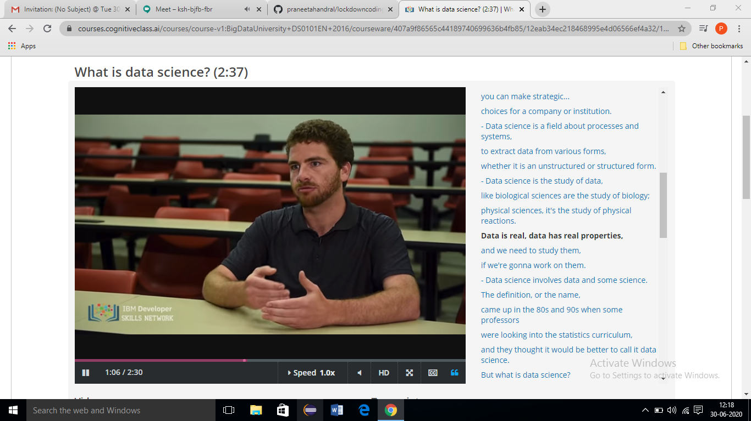

**Online Coding Summary​: Today I received two programs one from prof. Shilpa CSE Dept and another one from prof. Venkatesh CSE Dept I have written one program and uploaded it to my Github repository. This is my repository snapshot. I have uploaded the frequency program.**

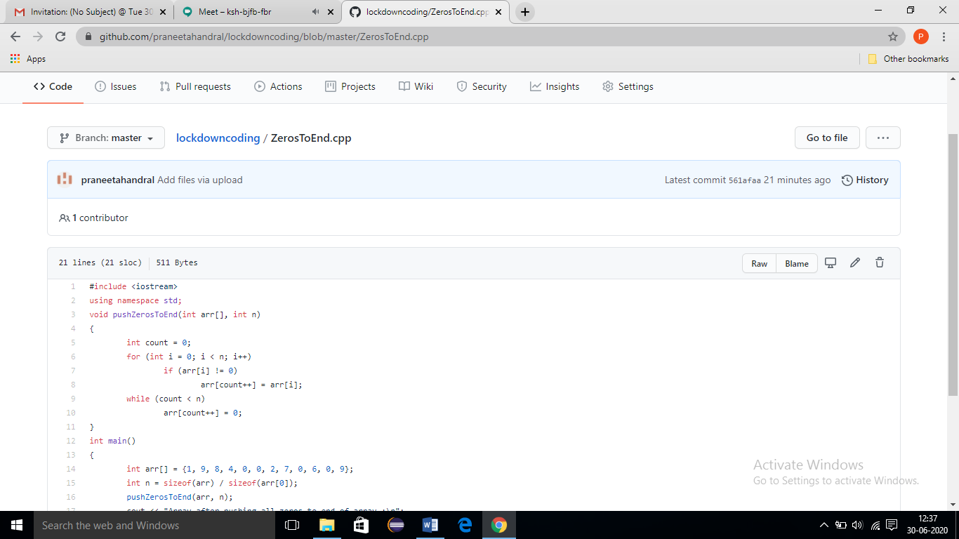

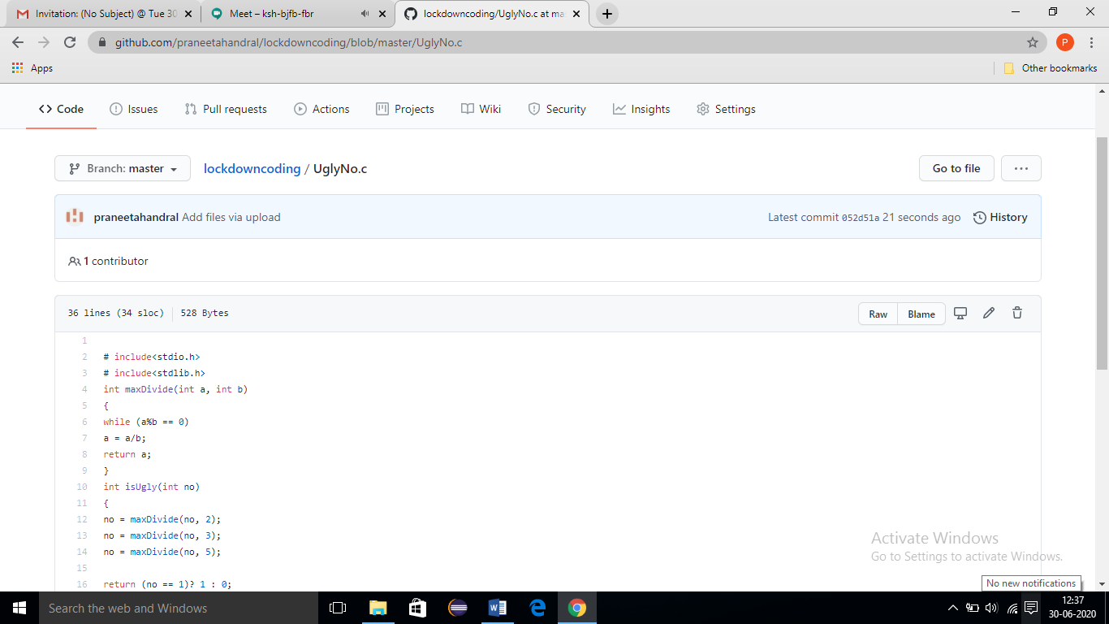

**Online Training**: Today I had attended the online training organized by CSE Dept AIET. The training was on C++ programming done by Prof. **Shruthi Shetty J** CSE Dept. After the session the quiz was conducted. the snapshot that shown in below quiz attempted and the marks obtained.

